**Obtaining dimensions from Solidworks ’22 Full Car Model**

Drawing of shaft:

Material: Steel.

Cross-section of steering assembly:

Half of U-joint from top of shaft - 24mm length:

Steering rack pinion – picture 1:

Steering rack pinion – picture 2:

Centre of Pinion to end of right of shaft: 52.66 – (19.3/2) + 43.01mm

I haven’t calculated the X and Y forces for my FBD analysis, as I’m not sure how to go about it. Looks like those forces would be from the weight of the shaft. However, I have done torsion calculations on both motor shaft and steering column shaft.

**FBD of steering system from pinion to top half of U-joint:**

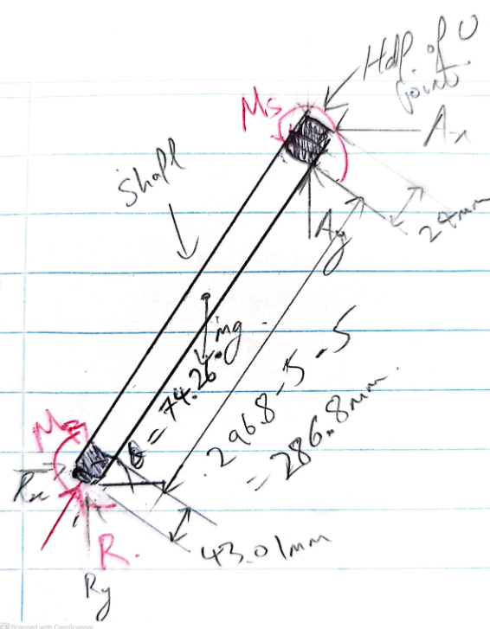

**Calculation – Motor Shaft Torsion:**

Polar moment of inertia of a solid bar, J:

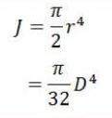

Using reasonable engineering judgement, 15mm diameter bar has been selected.

Shear Stress, τ:

Τ =

Using rated 9nm torque:

= 13.58 MPa

Using peak 18nm torque:

= 27.16 MPa

Allowable shear stress estimate for steel can be given as:

τallow​ ≈ 0.5*ultimate yield stress

From a resource for general properties of steel, the yield strength of steel is 350 MPa.

τallow​ ≈ 0.5*350 = 175 MPa

Since the allowable shear stress is 175 MPa, which is 12.89 times higher than the theoretical shear stress of 13.58 MPa in the shaft, the shaft can safely support a torque of 9nm. With 18nm, since 175 MPa is 6.44 times greater than 27.16 MPa, the shaft can also safely support the peak torque of 18nm.

**Calculation – Steering Shaft Torsion:**

Polar moment of inertia: Since the main shaft is hollow, the polar moment J for a hollow circular shaft must be used:

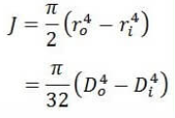

Shear Stress, τ:

Τ =

where T is the applied torque, r is the distance from the centre to the stressed surface.

**Autonomous condition: Torque applied to shaft via motor – 9nm rated torque:**

Using gear ratio of 2.86, the rated torque at the motor is 9nm, the torque at the driven is:

9nm x 2.86 = 25.74Nm.

Shear Stress, τ:

= 37.78 MPa

**Autonomous condition: Torque applied to shaft via motor – 18nm rated torque:**

Using gear ratio of 2.86, the rated torque at the motor is 18nm, the torque at the driven is:

18nm x 2.86 = 51.48Nm

Shear Stress, τ:

= 75.57 MPa

**Manual drive condition: Torque applied to shaft via steering wheel:**

Using 25nm from FOS of 16.6nm steering torque. Due to vector quantity, the torques are not .additive. When equal and opposite torques of 25 Nm are applied at both ends of the shaft, it results in a constant torque of 25 Nm on the shaft.

Shear Stress, τ:

= 36.7 MPa

Allowable shear stress estimate for steel can be given as:

τallow​ ≈ 0.5*ultimate yield stress

From a resource for general properties of steel, the yield strength of steel is 350 MPa.

τallow​ ≈ 0.5*350 = 175 MPa

**Autonomous condition: Torque applied to shaft via motor – 9nm rated torque:**

Since the allowable shear stress is 175 MPa, which is 4.6 times higher than the theoretical shear stress of 37.78 MPa in the shaft, the shaft can safely support a torque of 9 Nm.

**Autonomous condition: Torque applied to shaft via motor – 18nm rated torque:**

Since the allowable shear stress is 175 MPa, which is 2.3 times higher than the theoretical shear stress of 75.57 MPa in the shaft, the shaft can safely support a torque of 18 Nm with a reasonable factor of safety.

**Manual drive condition: Torque applied to shaft via steering wheel:**

Since the allowable shear stress is 175 MPa, which is 4.7 times higher than the theoretical shear stress of 36.7 MPa in the shaft, the shaft can safely support a torque of 25 Nm with a reasonable factor of safety.

**Calculation – Motor Shaft Torsion:**

Polar moment of inertia of a solid bar, J:



Shear Stress, τ:

Τ =

Using gear ratio of 2.86, the torque at the motor is 25nm (with FOS), the torque at the driven is:

25nm x 2.86 = 71.5Nm

= 45.5 MPa

Allowable shear stress estimate for steel can be given as:

τallow​ ≈ 0.5*ultimate yield stress

From a resource for general properties of steel, the yield strength of steel is 350 MPa.

τallow​ ≈ 0.5*350 = 175 MPa

Since the allowable shear stress is 175 MPa, which is 3.8 times higher than the theoretical shear stress of 41.7 MPa in the shaft, the shaft can safely support a torque of 25 Nm. This includes a factor of safety (FOS) of 1.5, based on a steering torque of 16.6 Nm.

## Radial Force Calculation

Method 1:

**Using formula from Flat Belt Tension and Bearing Force:**

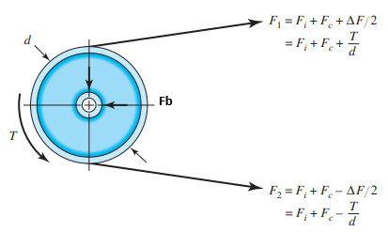

**Centrifugal Force Fc:**



Where m is the belt mass per unit length, r is the radius of pulley, and w is the rotational speed, and V is the belt speed.

The relationship between angular velocity and linear velocity:

V = rw

Expressing in terms of w in the equation:

Fc = mr(V/r)^2 = m (V^2/r)

Estimating the mass per unit length, m:   
m=ρ×A

For Gates Belt, chloroprene rubber density around 1.25 g/cm^3 (1300 kg/m^3)  
  
<https://analyzing-testing.netzsch.com/en-AU/polymers-netzsch-com/elastomers/cr-chloroprene-rubber>

m = 1300 kg/m^3 x (0.03m x 0.006) = **0.234 kg/m**

**Belt Speed:**



Pi*2.406in*200/12 = 125.98 ft/min (0.6399784 m/s)

**Fc =** m (V^2/r)

Fc = (0.234 kg/m x 0.6399784^2 m/s)/ 0.061m = 1.571N

**Determining relationship between F1 and F2**



Where f is the coefficient of friction, and angle of wrap θ.

Angle of wrap for smaller (driver) pulley:

θ1​=π+2arcsin((R2​−R1​​)/2)

= 3.46 radians

e^1.0x3.46 = F1/F2 = 31.85

Rearrange this to solve for F1​ in terms of F2​:



F1​−F2​= T/d = 18Nm/0.061m ​= 590.16 N

**Calculate F2:**  
  
Sub F1 = 31.85 x F2 into

F1 – F2 = 590.16N

31.85 x F2 – F2 = 590.16N

30.85 X F2 = 590.16N

**F2 = 19.13N**

**Calculate F1:**

F1 = 31.85 x F2 = 31.85 x 19.13 = **609.29N**

**Radial Force**

**Fr = F1 + F2**

Fr = 609.29N + 19.13 = 628.4N

Therefore the radial force on the bearing will be approximately 628.4N

**Calculate Shaft Bending Moment (M).**

The moment M acting of the motor bearing is given by:

Moment = Force x Distance

The driver pulley is 38mm in length. Let the pulley location on the shaft be half the pulley of 19mm width, plus a ~3mm from the motor hub

628.4N x ((38/2)+3x10^-3) = 13.82 Nm

**Calculate Bending Stress:**

Where y is the distance from neutral axis to the outer fibre, and I is the moment of inertia of a solid shaft, / 64. Let the motor shaft diameter d be 20mm.

Since the 35.2MPa is smaller than the yield strength 350 MPa for steel, a 20mm shaft diameter is adequate.

Combined Stress

**38mm**

Method 2:

Using this website for different method of load calculations:

[https://blog.orientalmotor.com/motor-sizing-basics-part-4-radial-load-and-axial-load#:~:text=Radial%20Load%20is%20defined%20as,%22hang%22%20off%20the%20shaft.](https://url.au.m.mimecastprotect.com/s/plQ9C1WLn2IM7v7O2FGhEHVc8tE?domain=blog.orientalmotor.com)

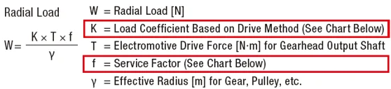

Using AK10-9 V2.0: ( K = 1.0, T = 16.6N, f = 1.2, y = 0.061m)

= **326.6N**

Using AK80-9: ( K = 1.0, T = 9, f = 1.2, y = 0.075m)

= **144N**

So both methods of calculations display similar results.

**References:**

<https://analyzing-testing.netzsch.com/en-AU/polymers-netzsch-com/elastomers/cr-chloroprene-rubber>

http://www.engineeringcorecourses.com/solidmechanics1/C3-torsion/C3.1-torsion-formula/theory/  
<https://www.matweb.com/search/datasheet.aspx?bassnum=MS0001&ckck=1>  
<https://www.eng-tips.com/viewthread.cfm?qid=463734>

https://www.youtube.com/watch?v=VbqCQ8fbqRo

**Appendices:**

